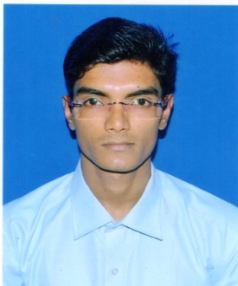 **RESUME**

**PRANAB BARIK**

Permanent Address:-VilL-BHIMARA,P.O-HARMASRA,P.S-TALDANGRA,Dist-BANKURA, PIN:722152,CONTACT-8972720279,Email-PRANABBARIK75@gmail.com

**CAREER OBJECTIVE**

To be a good engineer and loyal to work

**professional details**

* Father Name : MR. NARUGOPAL BARIK
* Date Of Birth : 03/05/1995
* Sex : Male
* Marital Status : Single
* Nationity : Indian
* Religion : hindu
* Caste : general
* PC Candidate : no

Q**ualification**

* General  **EDUCATION:**
* I have passed madhyamik examination under WBBSE board in the year of 2012 with 64.25% marks.
* **TECHNICAL QUALIFICATION**

|  |  |  |  |  |  |  |
| --- | --- | --- | --- | --- | --- | --- |
| EXAM PASSED | BOARD/  UNIVERSITY | SEMESTER | MONTH | YEAR OF PASSING | GRADE POINT(GPA) | PERCENTAGE |
| DIPLOMA IN MECHANICAL ENGINEERING | W.B.S.C.T.V.E.S.D. | 1st | December | 2014 | 7.8 | 70.8 |
| 2nd | May | 2015 | 6.7 | 64.9 |
| 3rd | December | 2015 | 7.4 | 72.4 |
| 4th | June | 2016 | 7.1 | 67.2 |
| 5th | December | 2016 | 8.2 | 77.5 |
| 6th | May | 2017 | 7.5 | 71.68 |

**TRAINING SKILL**

No.

**LANGUAGE KNOWN**

|  |  |  |  |
| --- | --- | --- | --- |
| READ | ENGLISH | BENGALI |  |
| WRITE | ENGLISH | BENGALI |  |
| SPEAK | ENGLISH | BENGALI | HINDI |

COMPUTER SKILL

I complete a course of COMPUTERAPPLICATION(BASIC), AUTO CAD

SKILL

Keen learner with constant zest to acquire new skills, Team player with strong analytical and leadership skill.

**INTEREST**

* **Subjects Of Interest**:-Production management, Drawing,Travelling, Listening Music, cricket ,Batminton etc.

**DICLERATION**

**I DECLEARE THAT ALL ABOVE MENTIONED PARTICULARS ARE TRUE TO MY BEST KNOWLEDGE.I WILL BE GREATFUL TO YOU IF YOU KINDLY GRANT ME THE OPPORTUNITY TO SERVE YOUR COMPANY.**

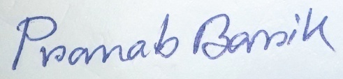

**……………………………………………………………**

**Signature**

**DATE:……………………………..**

**PLACE:…………………………………**